# C291 – System Programming in C and UNIX

## Bonus Assignment

### Task:

Write a C program to create and manipulate stack.

What is a stack?

Stack is an abstract data type that serves as a collection of elements, with two principal operations: push, which adds an element to the collection, and pop, which removes the most recently added element that was not yet removed. The order in which elements come off a stack gives rise to its alternative name, LIFO (for last in, first out). Additionally, a peek operation may give access to the top without modifying the stack.

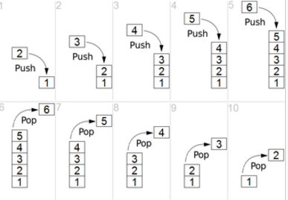

Figure 1: Reference Wikipedia

Your program should perform the following three functions

1. **Push – add an element to the top of stack**
2. **Pop – remove an element from the top**
3. **Peek – display the top element without removing the element**

**Note:** You are required to have node definitions in a different file, operations in another file and a separate file to interact with the user.

**Sample Output:**

**Enter an option**

1. **Push**
2. **Pop**
3. **Peek**
4. **exit**

**2**

**The stack is empty**

**Enter an option**

1. **Push**
2. **Pop**
3. **Peek**
4. **exit**

**1**

**Enter an element to push**

**5**

**Enter an option**

1. **Push**
2. **Pop**
3. **Peek**
4. **exit**

**1**

**Enter an element to push**

**6**

**Enter an option**

1. **Push**
2. **Pop**
3. **Peek**
4. **Exit**

**2**

**Removed element 6**

**Enter an option**

1. **Push**
2. **Pop**
3. **Peek**
4. **Exit**

**3**

**The top element is 5**

**NOTE: You are required to code only in open terminal. You should not use any IDE.**

Due Date:

The submission is due on Wed 06/15/2016 11:59 PM

What to turn in:

Commit your changes to your github repository. We’ll grade whatever version you’ve put there at 11:59PM on the due date.

Academic Integrity:

You may discuss the assignment with other people at a high level, e.g. discussing general strategies to solve the problem. You may also consult printed and/or online references, including books, tutorials, etc., but you must cite these materials in report. However, if you are submitting the code, then it must be your own work, which you personally designed and wrote. You may not share written code with any other students, nor may you possess code written by another student either in whole or in part, regardless of format. The professor and AI’s are always available to help, so reach out through canvas if you need one!

### Rubric:

* You will get 50% of total marks on successful compilation of program without any errors
* You will get 70% of total marks on successful execution of program
* You will get 90% of total marks on passing all test cases
* You will get 100% of total marks based on your code clarity
* The following falls under clean code
  + Proper names for variables.
  + Follow camel case patterns.
  + Comment where ever needed
  + Output unambiguous & user friendly messages